Chapter 14, Solution 97.
L
R_{L}
R_{i}
+
-
V_{i}
V₁
V_{o}
+
V_{o}
-
C₁
C₂
Z₂
Z₁

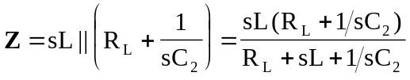, 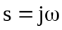

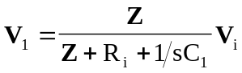

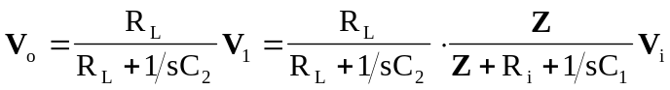

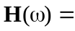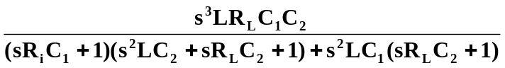

where .

